**TOWSON STUDENT TUTORING SERVICES**

**(Final Project)**

Installment of Project

Website: <https://repl.it/@thebeardedgreek/Towson-Tutoring>

1. To use this product first click on the website. It will direct you straight to the website with the code and everything. You should be directed to a screen like this.

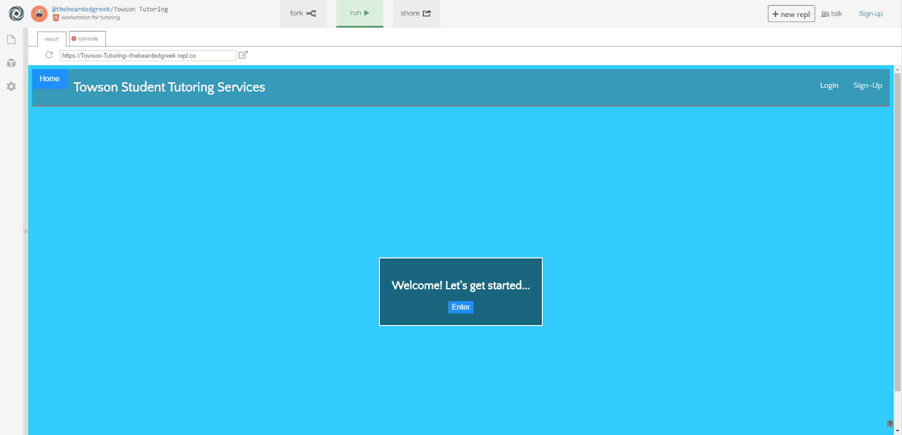

1. After this pop up, press “Run “ so the code will compile. Then when it reloads. Click on the “Enter” button.  After clicking it it will prompt you to the next screen when it will ask you some questions.

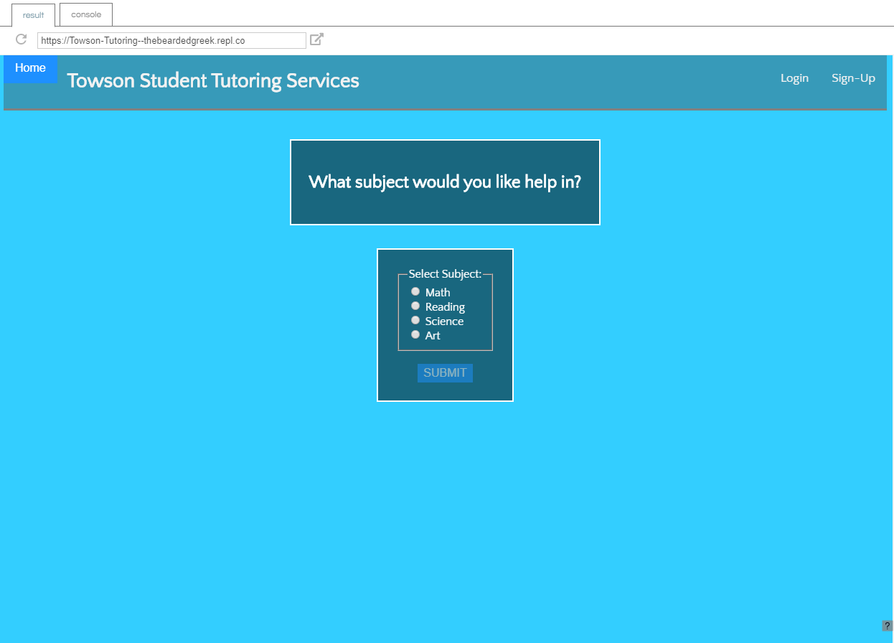

1. Continue to answer each question and click “Submit” till you get to the page that has populated a list of different tutors. You can cycle through different tutors up to 179 tutors.

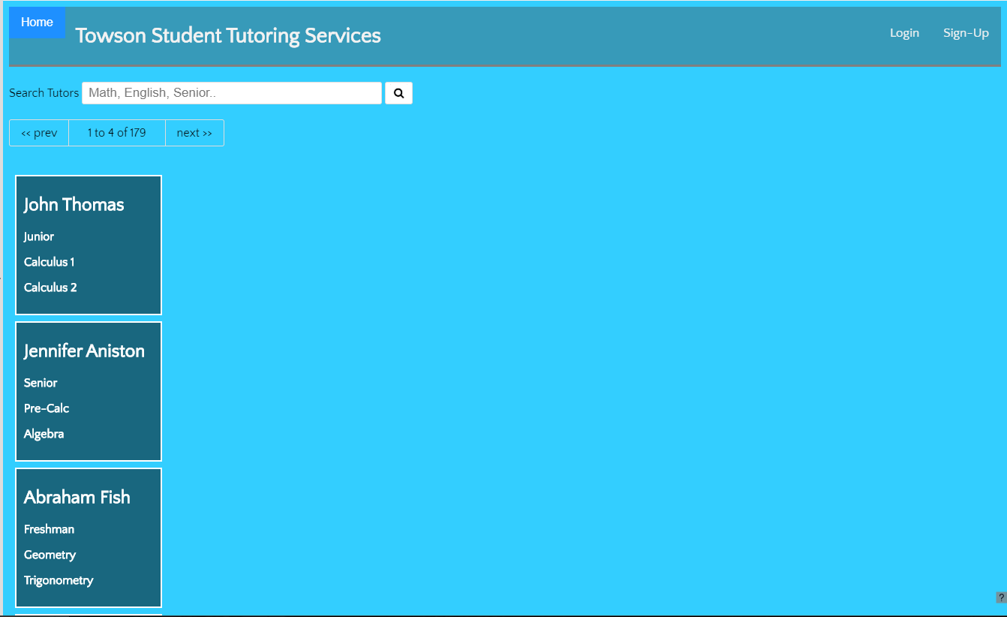

1. By clicking “Home” it will take you back to the home screen. To create an account click on “Account Management”. Fill in the information to register and create an account.

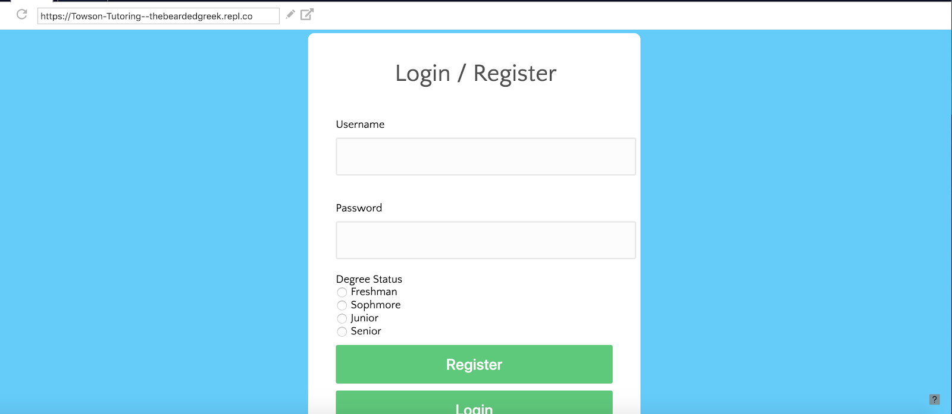

1. If you already have a profile, you can go straight to the “Login” page. Just fill out the necessary information.

